

**North South University**

# Department of Electrical & Computer Engineering

**LAB REPORT**

Course Code: EEE141L

Course Title: Electrical Circuits I Lab

Course Instructor: Dr. Mohammad Abdul Matin (Mtn)

Experiment Number: 3

Experiment Name:

|  |
| --- |
| Loading Effect of Voltage Divider Circuit |

Experiment Date: 18/3/2021

Date of Submission: 24/3/2021

Section: 3

Submitted To: Tabia Hossain

|  |  |
| --- | --- |
| Submitted By | Score |
| Student Name and ID:  1. Md. Rifat Ahmed - 1931725042 |  |

**Objectives:**

• To analyze how the voltage divider circuit behaves when there is no load resistance connected.

• Evaluate the performance of voltage divider circuit due to loading.

**List of Equipment:**

• OrCAD Software

• PSpice Software

• 2 × 560Ω Resistors

• 1 × (0-10kΩ) Variable resistor

**Theory:**

**Voltage Divider Rule:**

If two or more resistors are connected in a series circuit, then the source voltage gets divided among the resistors and the higher the resistance the higher voltage drop will occur at that resistor.

For example, in figure − 1 the R1 and R2 resistors are connected in a series circuit so the source voltage E will get divided among them as V1 and V2.

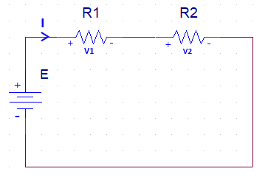

Figure − 1

And the way to calculate the voltage drops in a 2 resistor series circuit is,

V1 = × E

V2 = × E

And if we want to calculate the voltage drops for a circuit with more than 2 resistors connected in series we can follow a similar approach,

Vx = x E

Where, E is the source voltage, RX indicates the resistor we’re trying to find the voltage drop (VX) at and n indicates the total number of resistors.

**Loading Effect:**

Due to some extra load on a circuit the impact or the change in the electrical properties is called the loading effect.

For example, if we add a parallel load resistor to R2 in figure – 2 (A) the voltage output of R2 resistor will change because of the extra added load and this change is called loading effect.

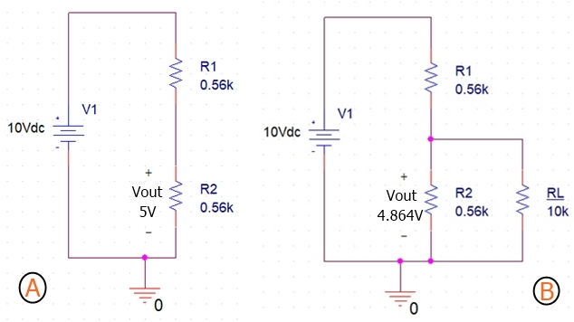

Figure – 2: (A) 2 Resistor Series Circuit,

(B) Added a Load Resistor to R2 of the same circuit

**Circuit Diagram:**

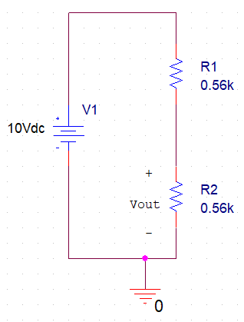

**Circuit – 1**

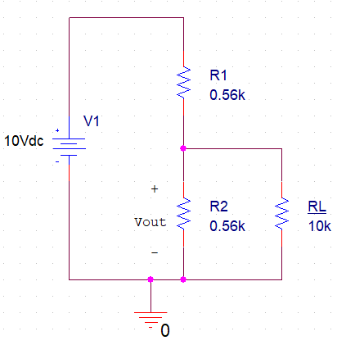

**Circuit – 2**

**Data, Readings and Results:**

|  |  |  |  |
| --- | --- | --- | --- |
| **RL** | **Vout**  **(Measured)** | **Vout**  **(Calculated)** | **% Error** |
| **No resistor** | 5V | 5V | 0% |
| **1k** | 3.906V | 3.906V | 0% |
| **4k** | 4.673V | 4.672V | 0.02% |
| **7k** | 4.808V | 4.810V | 0.04% |
| **10k** | 4.864V | 4.862V | 0.04% |

**Questions and Answers:**

**Answer of Question 1:**

At the beginning with no extra load resistor the value of Vout was 5V but when we added a 1k load the value of Vout decreased to 3.906V but then again after increasing the load to 4k we got 4.673V, then for 7k load we got 4.808V and then for 10k load we got 4.864V. So the value of Vout drops for low load resistors but as we keep increasing the load the value of Vout keeps increasing as well and if we keep increasing the load to a lot bigger number we’ll finally be able to get to a point where the load won’t have any significant effect on our resistor and we’ll get the same Vout as we got without any extra laod.

**Answer of Question 2:**

Given,

E = 10 V

R1 = 560 Ω = 0.56kΩ

R2 = 560 Ω = 0.56kΩ

Now Calculating the values of Vout for each load resistor,

With no resistor,

RS = R1 + R2 = 0.56kΩ + 0.56kΩ = 1.12kΩ

؞ Vout = × R2 = × 0.56 = 5V

For RL = 1k,

RP = = = 0.359kΩ

RS = R1 + RP = 0.56kΩ + 0.359kΩ = 0.919kΩ

؞ Vout = × RP = × 0.359 = 3.906V

For RL = 4k,

RP = = = 0.491kΩ

RS = R1 + RP = 0.56kΩ + 0.491kΩ = 1.051kΩ

؞ Vout = × RP = × 0.491 = 4.672V

For RL = 7k,

RP = = = 0.519kΩ

RS = R1 + RP = 0.56kΩ + 0.519kΩ = 1.079kΩ

؞ Vout = × RP = × 0.519 = 4.810V

For RL = 10k,

RP = = = 0.530kΩ

RS = R1 + RP = 0.56kΩ + 0.530kΩ = 1.09kΩ

؞ Vout = × RP = × 0.530 = 4.862V

**Answer of Question 3:**

From the table we get,

When there’s no load resistor added for RL,

V(Measured) = 5V

V(Calculated) = 5V

؞ % Error for no resistor= $|\frac{Experimental value - Theoretical value }{Theoretical value }|$ × 100%

= $|\frac{5-5}{5}|$ × 100% = 0%

For RL = 1k,

V(Measured) = 3.906V

V(Calculated) = 3.906V

؞ % Error for 1k= $|\frac{Experimental value - Theoretical value }{Theoretical value }|$ × 100%

= $|\frac{3.906 - 3.906}{3.906}|$ × 100% = 0%

For RL = 4k,

V(Measured) = 4.673V

V(Calculated) = 4.672V

؞ % Error for 4k= $|\frac{Experimental value - Theoretical value }{Theoretical value }|$ × 100%

= $|\frac{4.673 - 4.672}{4.672}|$ × 100% = 0.02%

For RL = 7k,

V(Measured) = 4.808V

V(Calculated) = 4.810V

؞ % Error for 7k= $|\frac{Experimental value - Theoretical value }{Theoretical value }|$ × 100%

= $|\frac{4.808 - 4.810}{4.810}|$ × 100% = 0.04%

For RL = 10k,

V(Measured) = 4.864V

V(Calculated) = 4.862V

؞ % Error for 10k= $|\frac{Experimental value - Theoretical value }{Theoretical value }|$ × 100%

= $|\frac{4.864 - 4.862 }{4.862}|$ × 100% = 0.04%

Here, we can see that the % error with no load resistor and 1k load resistor is zero and for 4k, 7k and 10k load resistors the % error is very close to zero. So, it can be said that the loading effect of our circuit supports the theory as the experimental data is almost the same as our calculated theoretical data.

**Discussion:**

From this experiment we’ve learned what’s loading effect and again we used the voltage divider rule to get the value of the voltage that was going out of the 2nd resistor where we connected different load resistors to see the difference in loading effect and the variation in the value of Vout. And as for the result, our experimental values and the theoretical values were almost the same and which is why we got % error very close to zero. So, our practical results were almost the same as the theoretical results that we calculated. Overall, we didn’t face that much of a problem during this experiment as we were already familiar with the concept of voltage divider rule so we just had to make sure that our calculations are correct for this experiment to be done perfectly.